**Kafka Topics and Partitions**

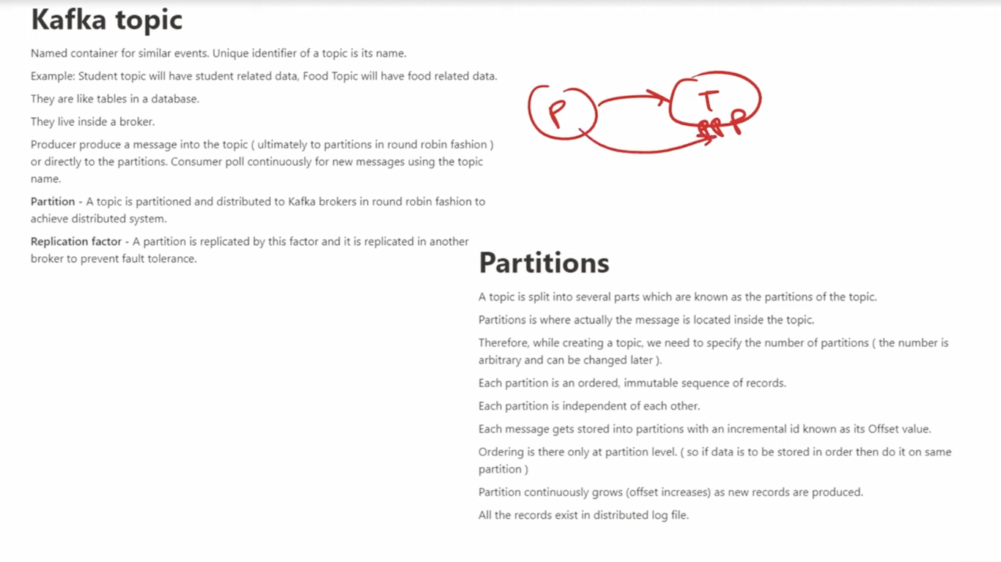

**Topic** is like a table similar kind of data is in one table so similar kind of data in topics Eg food data in Food Topic.

In topic we have partitions. Kafka Producer sends data into topic (ultimately to partition in round robin fashion) or directly to partions.

**Partitions:**

A topic is split into several parts which are known as the partition of a topic.

